By: Abdallah Ahmed Abbas

s-abdallah.abbas@zewailcity.edu.eg

**On-demand Traffic light control**

Embedded systems professional by Udacity

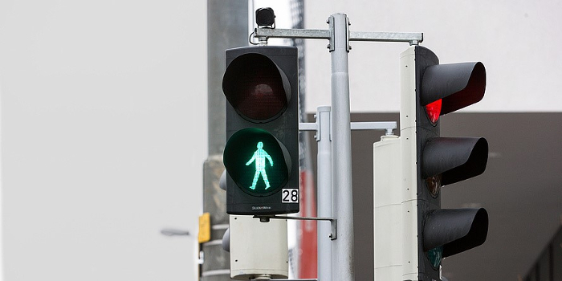

**Content table.**

1. System description………………………………………………………..
2. System design……..………………………………………………………..
3. Flow chart……………..………………………………………………………
4. System constraints…………………………………………………………
5. **System description:**

Traffic light is a very important system used to control car movement in the street to avoid traffic jams and help people to cross the road. The provided system offer smooth flow to help people to cross the road using a button and the traffic LEDs. This system has to modes which are the normal mode and pedestrian mode which the system get into by pushing the provided button by the user.

1. **System hardware:**
2. ATmega32 microcontroller.
3. button.
4. 6 LEDs.
5. 7 resistors.
6. Ground.
7. Power supply.

1. **Flow chart:**

Normal:

Pedestrian:

1. System constrains:

The system is by default in normal mode, to change to pedestrian mode you should push the button one short push. Long push or serval pushes do not have special function. If the button has been pushed while the green car led is on, the yellow LEDs for the car and the pedestrian will plink then the red car LED and green pedestrian LED be on, while if red and yellow LEDs are on the user will have to wait for 5 seconds then pedestrian green light be on, however if car red LED and pedestrian green LED are on, pushing the button will do nothing to the system.